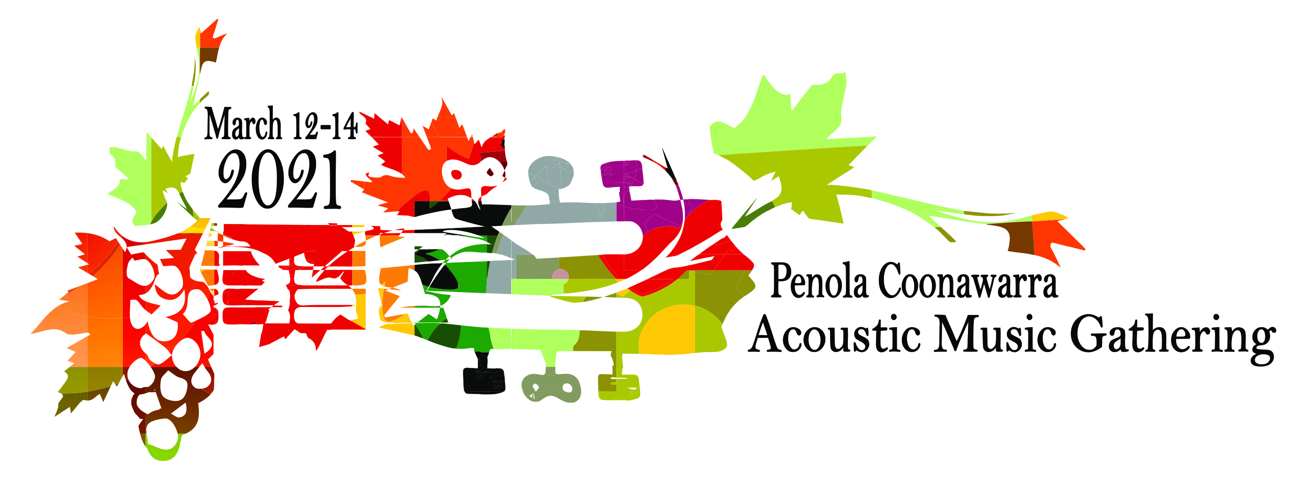
YOUTH MENTORING PROGRAM
I would like to attend the Youth Mentoring Program and I am interested in: (you may select more than one!)
- preparation before the performance

- stage presentation

- song writing

- hints and tips on playing specific instruments

- other

…………………………………………………………………………………………………….
Name: Phone:
Address:
Email:
Age:
What instrument(s) do you play?:
How long have you been performing?
Do you have any dietary preferences?
………………………………………………………………………………………………………..
Please return the form to: pcmusicgathering@ gmail.com
Anne Miller, Program Coordinator: 0434 536 297
www.pcmusicgathering.com.au
Penola Coonawarra Acoustic Music Gathering | Facebook .
WE LOOK FORWARD TO SEEING YOU!

